Image Colour Compressor

Abstract
This project presents an Image Colour Compressor, a web-based tool that reduces the number of unique colours in a digital image using unsupervised machine learning. High-resolution images often contain millions of distinct RGB colour combinations, which increases file complexity and is unnecessary for many practical use cases such as stylised graphics, printing, and lightweight image storage. The system applies MiniBatchKMeans clustering to group an image's pixels by colour similarity, replacing each pixel with the average colour of its assigned cluster. Users interact with the tool through a Streamlit-based interface, uploading an image and selecting a target number of colours (K) via a slider. The backend reshapes the image into a matrix of RGB values, fits a clustering model, and reconstructs a compressed version of the image for display and download. The application was deployed publicly using Streamlit Community Cloud, with source code hosted on GitHub. Performance was evaluated using clustering inertia across multiple K values via the elbow method, alongside qualitative visual comparison at different compression levels. The tool is lightweight, runs entirely in-browser once deployed, and requires no labelled training data, making it a practical demonstration of unsupervised learning applied to a real, interactive product.

Chapter 1: Introduction

1.1 Background of the Study
Digital images are typically stored using the RGB colour model, where each pixel is represented by three values (Red, Green, Blue), each ranging from 0 to 255. This allows for over 16.7 million possible colours per pixel. While this range enables photographic realism, many applications do not require such colour fidelity. Retro-style graphics, posterised artwork, simplified image previews, and certain compression formats all benefit from a reduced colour palette. Historically, colour quantization — the process of reducing the number of distinct colours in an image — has been handled using fixed palettes or basic averaging techniques. Machine learning offers a more adaptive alternative: by treating each pixel as a data point in 3-dimensional colour space, an unsupervised clustering algorithm can automatically discover the most representative colours for a specific image, rather than relying on a generic, predefined palette.

1.2 Problem Statement
Users who want to reduce an image's colour complexity — whether for stylistic, storage, or compression purposes — generally lack an easy, interactive, adaptive tool to do so. Most existing solutions either use fixed colour palettes that do not adapt to the specific image, or require desktop image-editing software with a learning curve. There is a need for a simple, web-accessible tool that intelligently reduces an image's colour palette based on the image's own content, with user control over the level of compression.

1.3 Aim and Objectives
Aim: To develop a web-based tool that uses unsupervised machine learning to compress an image's colour palette to a user-specified number of colours, while preserving overall visual structure.
Objectives:
- To preprocess uploaded images by reshaping pixel data into a format suitable for clustering.
- To implement MiniBatchKMeans clustering to group image pixels by colour similarity and generate a reduced colour palette.
- To evaluate clustering quality across different values of K using inertia and the elbow method.
- To build and deploy an interactive Streamlit web interface allowing users to upload images, adjust compression level, and download results.

1.4 Significance of the Project
This project demonstrates a practical, end-to-end application of unsupervised machine learning — from raw data (pixel values) to a deployed, user-facing product. It is useful for designers and hobbyists seeking stylised image effects, for understanding image compression concepts, and as an educational demonstration of how clustering algorithms operate on real, non-tabular data. It also showcases the engineering trade-offs involved in deploying ML models in a responsive web application, such as balancing processing speed against output precision.

1.5 Scope and Limitations
This project was developed within a 3-week timeline and focuses specifically on static image colour compression using K-Means-based clustering. It does not cover video processing, lossless compression, or advanced perceptual colour models (e.g., CIE Lab space). The tool processes one image at a time and depends on the computational resources available through free-tier cloud deployment, which may affect processing speed for very large images. The system does not include user accounts, image history, or batch processing in its current scope.

Chapter 2: Technical Background & Literature Review

2.1 Overview of the Domain Landscape
Traditional colour quantization methods include the median cut algorithm and octree quantization, both of which partition colour space using fixed geometric or statistical rules rather than learning from the specific distribution of pixel colours in an image. Modern approaches increasingly use clustering algorithms from machine learning, which adaptively identify the most representative colours for each individual image rather than applying a one-size-fits-all palette. This project adopts the clustering-based approach, specifically K-Means and its faster variant, MiniBatchKMeans.

2.2 Theoretical Framework
K-Means Clustering: K-Means is an unsupervised learning algorithm that partitions a set of data points into K groups (clusters), such that each point belongs to the cluster with the nearest mean (centroid). The algorithm proceeds iteratively:
- Initialize K centroids (randomly or via a smart initialization method).
- Assign each data point to its nearest centroid, based on Euclidean distance.
- Recalculate each centroid as the mean of all points assigned to it.
- Repeat steps 2–3 until centroid positions stabilise (convergence).
In this project, each data point is a single pixel represented as a 3-dimensional vector of its Red, Green, and Blue values. An image with height H and width W is reshaped from a (H, W, 3) array into a (H×W, 3) matrix, where each row is one pixel's colour. K-Means is then applied to this matrix, treating colour similarity as spatial proximity in RGB space.
MiniBatchKMeans: Standard K-Means recalculates cluster assignments using the entire dataset at every iteration, which becomes computationally expensive for images containing millions of pixels. MiniBatchKMeans addresses this by using small, randomly sampled batches of the data at each iteration instead of the full dataset, substantially reducing computation time while converging to cluster centres very close to those found by standard K-Means. This trade-off was selected deliberately for this project to maintain a responsive user experience in a web application, where users expect results within a few seconds rather than tens of seconds.
Evaluating Cluster Quality — Inertia: Inertia measures the sum of squared distances between each point and its assigned cluster centroid. Lower inertia indicates tighter, more cohesive clusters. However, inertia decreases monotonically as K increases (more clusters naturally reduce average distance to the nearest centroid), so the lowest-inertia K is not necessarily the best choice. The elbow method addresses this by plotting inertia against increasing K values and identifying the point where additional clusters yield diminishing returns — the "elbow" of the curve.

2.3 Ethical & Privacy Considerations
This project processes only the pixel colour data of user-uploaded images and does not perform facial recognition, identity inference, or any form of personal data extraction. Images are processed transiently during a user's session and are not stored, logged, or reused. The primary ethical consideration is transparency: the tool is explicitly a stylistic/compression effect, and reduced-colour output should not be presented as a faithful reproduction of the original image. Users uploading images retain full responsibility for ensuring they hold appropriate rights to any images processed through the tool.

Chapter 3: Methodology & System Architecture

3.1 Data Engineering Pipeline
Data Source: Unlike typical supervised ML projects, this system does not use a pre-existing labelled dataset. Instead, each user-uploaded image serves as the input data at runtime. Sample images used for development and testing were sourced from personal photos and publicly shareable images.
Preprocessing: Uploaded images are opened and converted to RGB format (ensuring exactly 3 colour channels, since some formats such as PNG may include a 4th alpha/transparency channel). The image is then converted into a NumPy array of shape (height, width, 3) and reshaped into a two-dimensional array of shape (height × width, 3), where each row represents one pixel's RGB values. This reshaping step is essential because K-Means operates on a flat list of data points, not a spatial grid.
Data Augmentation: Not applicable to this project, as no model is being trained on a fixed dataset — clustering is performed fresh on each uploaded image's own pixel data.

3.2 Model Selection and Training Configuration
The core algorithm used is MiniBatchKMeans from the scikit-learn library, selected over standard KMeans to balance clustering precision with processing speed in a browser-based, user-facing application. Key configuration:
- n_clusters (K): user-adjustable via a slider (range: 2–32), representing the desired number of output colours.
- n_init = 3: the algorithm is run with 3 different centroid initializations, and the best result (lowest inertia) is kept, balancing reliability against computation time.
- batch_size = 1024: each iteration samples 1024 pixels rather than the full pixel set, significantly reducing computation per iteration.
- random_state = 42: fixed seed to ensure reproducible results across runs.
Unlike neural network training, K-Means has no concept of epochs, learning rate, or loss backpropagation — it converges through iterative centroid reassignment until cluster positions stabilise. Training (fitting) occurs in-browser-session, on Streamlit Community Cloud's shared computing environment, rather than on a dedicated GPU, which was sufficient given the lightweight nature of the clustering task.

3.3 System Architecture Design
The system follows a simple linear pipeline:
- User uploads an image via the Streamlit file uploader widget.
- Image preprocessing: the image is converted to RGB and reshaped into a pixel-colour matrix.
- Clustering: MiniBatchKMeans fits on the pixel matrix, producing K cluster centroids (the new colour palette) and per-pixel cluster labels.
- Image reconstruction: each pixel is replaced with its assigned cluster's centroid colour, and the flat pixel array is reshaped back into the original image dimensions.
- Output display: both the original and compressed images are displayed side-by-side in the browser.
- Download: the compressed image is encoded into an in-memory PNG buffer and offered to the user via a download button.
(A block diagram illustrating this pipeline — User Upload → Preprocessing → Clustering Model → Image Reconstruction → Display/Download — should be inserted here as a figure.)
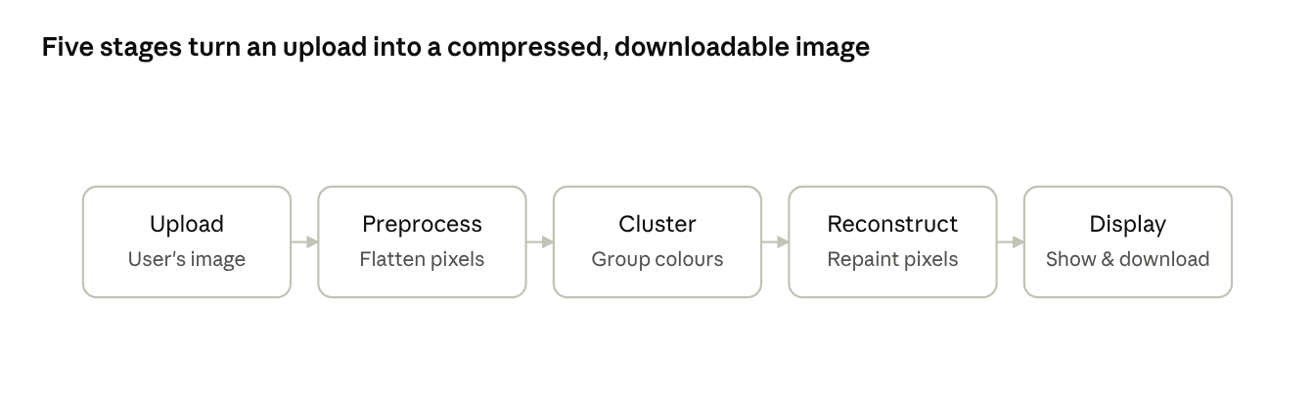
pipeline · 5 stages, upload to download
Data moves left to right: each stage hands its output to the next, ending with a file the user can save.

3.4 User Interface & Deployment Strategy
The frontend and backend logic are unified using Streamlit, a Python framework that converts scripts into interactive web applications without requiring separate frontend code (HTML/CSS/JavaScript). Key UI elements include a file uploader, a slider for selecting K, and image display components for both original and compressed outputs, alongside a download button.
For deployment, the project's source code (app.py and requirements.txt) was pushed to a public GitHub repository. The application was then deployed using Streamlit Community Cloud, which connects directly to the GitHub repository, installs the dependencies listed in requirements.txt (streamlit, numpy, pillow, scikit-learn), and hosts the app at a permanent, publicly accessible URL. This approach was chosen over a local-only solution (such as ngrok tunnelling from Google Colab) because it provides a stable link that remains active independent of any individual device or session, fulfilling the Appendix requirement for a live, deployed application link.

Chapter 4: Results, Evaluation & Discussion

4.1 Model Performance Evaluation
Since this is an unsupervised clustering task rather than a classification or regression problem, standard metrics such as accuracy or F1-score are not applicable. Instead, clustering quality was evaluated using inertia across a range of K values (e.g., K = 2 to 20), plotted as an elbow curve. The resulting plot showed a steep decline in inertia at low K values, flattening noticeably beyond a certain point the elbow indicating diminishing returns from additional clusters past that threshold. This point was used to justify the default K value offered to users in the application interface.
(Insert the elbow plot — inertia vs. K — generated from the app here as a figure.)
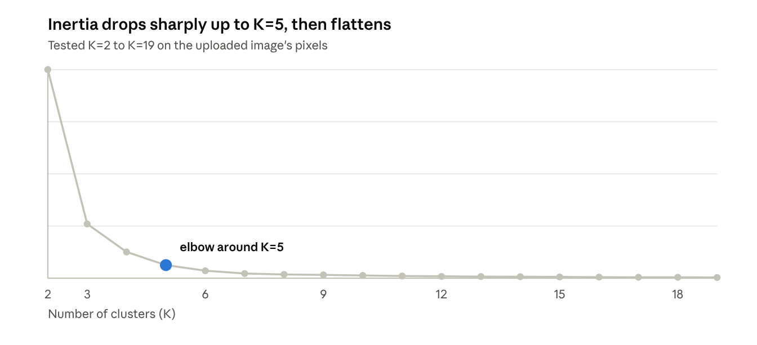
from the app's K-Means run on the uploaded sample image · K=2–19
The elbow sits around K=5 — beyond this point, adding more clusters barely reduces inertia further.

4.2 User Interface Live Test Cases
The deployed application was tested with multiple sample images of varying colour complexity. For each test, the original image was uploaded, and the compressed output was generated at several K values (e.g., K = 4, 8, 16, 32) to visually demonstrate the compression effect.
(Insert screenshots here: original image, and compressed outputs at K = 4, 8, 16, and 32, side by side.)
Original

K = 4

K = 8

K = 16

K = 32

At low K values (e.g., K = 4), the output image showed strong posterisation, with large flat regions of colour and visible loss of gradient detail. At higher K values (e.g., K = 32), the compressed image was visually very close to the original, with subtle colour banding only noticeable on close inspection. This confirms the expected trade-off: lower K produces more dramatic compression and stylisation, while higher K preserves more visual fidelity.

4.3 Analysis of Failure Modes (Edge Cases)
- Smooth gradients: Images containing smooth colour transitions (e.g., skies, skin tones) show visible "banding" artifacts at low K values, as the limited palette cannot represent gradual change.
- High-detail/busy images: Images with many fine details and varied colours require a higher K to remain visually coherent; at low K, important details can be lost or merged into surrounding colour regions.
- MiniBatchKMeans variability: Because MiniBatchKMeans samples random batches rather than using the full pixel set at every step, there is minor run-to-run variability in exact cluster placement compared to standard KMeans. This was mitigated by fixing random_state=42 for reproducibility and using n_init=3 to reduce the chance of a poor-quality clustering result.
- Large image processing time: Very high-resolution images (e.g., several megapixels) still take a few seconds to process on free-tier cloud hosting, representing a practical limitation of the deployment environment rather than the algorithm itself.

Chapter 5: Conclusion & Future Work

5.1 Summary of Findings
Over the course of this 3-week sprint, an end-to-end image colour compression tool was successfully developed, using MiniBatchKMeans clustering to reduce an image's colour palette based on its own pixel data. The tool was wrapped in an interactive Streamlit interface, allowing users to upload images, adjust the number of output colours, view before/after comparisons, and download results. The application was deployed publicly via Streamlit Community Cloud with source code hosted on GitHub, fulfilling the project's goal of producing a usable, accessible web tool rather than a purely offline script.

5.2 Conclusion
This project demonstrates that unsupervised clustering algorithms, despite their mathematical simplicity relative to deep learning models, can be applied effectively to real, non-tabular data such as images, producing a genuinely useful and interactive tool. The engineering decision to use MiniBatchKMeans over standard KMeans illustrates a practical trade-off common in applied machine learning: balancing computational efficiency against output precision to meet real-world usability constraints, particularly for browser-based applications where users expect near-instant feedback.

5.3 Recommendations for Future Work
Given a longer development window (e.g., 6 months), this prototype could be extended in several directions:
- Perceptual colour clustering: Clustering in a perceptually uniform colour space (such as CIE Lab) instead of raw RGB, which may produce visually more natural colour groupings.
- Automatic K selection: Implementing an automatic elbow-detection algorithm so the tool can suggest an optimal K value rather than requiring manual slider adjustment.
- Batch processing: Allowing users to upload and process multiple images at once.
- Video support: Extending the pipeline to apply colour compression frame-by-frame to short video clips.
- Edge deployment: Migrating processing to run client-side (e.g., via WebAssembly) or on lightweight edge hardware, reducing dependency on cloud server resources and improving processing speed further.

Appendix
- Live deployed application: https://image-colour-compress.streamlit.app/
- GitHub repository (source code): https://github.com/TechCrush-ImageColourCompressor/Image-colour-compressor-2.git

